caNanoLab 1.2.1

Title of Publication

Installation Guide






Center for Bioinformatics

October 17, 2007
Table of Contents

Introduction to caNanoLab 1
Targeted Developer 1
Important Background Knowledge 1
General System Requirements 2
Open Source Technologies 2
Grid Service 2
Grid Service Downloads 2
Obtaining the caNanoLab Source 3
Source Code 3
Database Technology 3
Assumptions and Requirements 3
For a Previous Installation 3
For a New Installation 3
Initializing the MySQL Database 4
Follow these steps to initialize your MySQL database system: 4
Verification 5
Data Migration 5
caNanoLab Web Application 12
Assumptions and Requirements 12
Installation and Deployment 12
Common Security Module (CSM) 13
Before You Start caNanoLab 13
Verification 15
User Provisioning Tool (UPT) 15
UPT Example 16
caNanoLab Grid Data Service 18
Assumptions and Requirements 18
Installation and Deployment 18
Verification 20
Contacting Application Support 20

Introduction to caNanoLab
Welcome to the cancer Nanotechnology Laboratory Analysis Bench (caNanoLab) 1.2.1 Installation Guide. caNanoLab is a data sharing portal designed for laboratories performing nanoparticle assays. caNanoLab provides support for the annotation of nanoparticles with characterizations resulting from physical and in vitro nanoparticle assays and the sharing of these characterizations in a secure fashion.
As of release 1.1, the caNanoLab domain model has been caGrid enabled. In other words, a caNanoLab grid data service can be deployed and registered with caGrid 1.0 index server, allowing sharing of public characterizations across the caGrid. For more information, see https://cabig.nci.nih.gov/workspaces/Architecture/caGrid. The caNanoLab web application now allows remote searches against remote grid services hosting the caNanoLab data model.

Targeted Developer
Although the installation instructions have been simplified as much as possible, this installation guide is best suited for an experienced java developer who has some familiarity with the following J2EE and related technologies:
Important Background Knowledge | - Unix/Linux environment  - (Configuring environment variables; Installing Ant, JDK, Apache Tomcat and JBoss servers)  - Ant build scripts  - J2EE web application development using the Struts framework, Servlet/JSP’s, JavaScript  - J2EE middle-ware technologies such as n-tier service-oriented architecture and software design patterns  - caGrid 1.0 infrastructure (for setting a caNanoLab grid data service)

General System Requirements
The following open source technologies power a caNanoLab web application:

Open Source Technologies | - Java Software Development Kit (JDK) version 5.0 http://java.sun.com/javase/downloads/index_jdk5.jsp  - JBoss version 4.0.5 http://labs.jboss.com/jbossas/downloads  - Jakarta Ant version 1.6.5 http://archive.apache.org/dist/ant/binaries/  - MySQL version 5.0.x http://dev.mysql.com/downloads/mysql/5.0.html

The caNanoLab web application has been tested within NCICB against JBoss servers hosted on Windows XP and RedHat Linux systems, and against MySQL 5.0.27 databases hosted on RedHat Linux systems and MySQL 5.0.45 on Windows XP systems. Prior to release 1.2.1, the caNanoLab web application had been tested against Oracle 9i databases hosted on Sun Solaris systems, and Oracle 10g XE database hosted on Windows XP.

Download each of the tools listed in the bulleted list and follow the installation instructions provided with each respective product for your environment. Assistance from a MySQL database administrator is expected to properly configure the MySQL database. For MySQL database configuration and maintenance, it is also helpful to download the MySQL 5.0 suite of GUI tools at http://dev.mysql.com/downloads/gui-tools/5.0.html.

Grid Service | Setting up a caNanoLab grid service is optional. It is recommended that you install the grid service only after you successfully install the web application and become familiar with submitting and searching data through the web application.

Grid Service Downloads | Once you have data that you would like share with the caBIG community and you intend to set up a caNanoLab grid service, download the following open source technologies that power a caNanoLab grid data service:  - The Globus Toolkit version 4.0.3 http://www.globus.org/  - Apache Tomcat version 5.0.28 http://tomcat.apache.org/

Obtaining the caNanoLab Source
Source Code | The caNanoLab web application source code is distributed as a zip file named caNanoLab_1.2.1.zip from the NCICB download center at http://ncicb.nci.nih.gov/download/.  There are no source updates related to the caNanoLab grid service. The caNanoLab grid service source code is distributed as a zip file named caNanoLab_grid_1.1.zip from the NCICB download center at http://ncicb.nci.nih.gov/download/.

Database Technology

Assumptions and Requirements | The caNanoLab source distribution caNanoLab_1.2.1.zip has been downloaded from the NCICB download site. A MySQL database has been set up on a system (local or remote) with an administrator (or root) account. You should be familiar with the process of creating InnoDB tablespaces, databases creating users and assigning privileges to users.

For a Previous Installation | If you have installed caNanoLab release 1.2 or release 1.1.1 or release 1.1 against an Oracle database and have associated production data in these schemas and you would like to continue to use the same schemas for caNanoLab release 1.2.1 in MySQL, review the following database initialization steps, then go directly to Data Migration on page 5.

For a New Installation | If you are installing the caNanoLab application for the first time or want to install a new schema for release 1.2.1, follow the steps below to set up the required MySQL schema objects and the seed data for release 1.2.1.

Initializing the MySQL Database

Follow these steps to initialize your MySQL database system:
Step | Action
1 | Extract the caNanoLab_1.2.1.zip to a location on your local system, for example, C:\caNanoLab_1.2.1. This location is referred as <CANANOLAB_SOURCE> throughout the document. Verify that the following seven SQL scripts exist in the directory <CANANOLAB_SOURCE>/db/1.2.1:  - app_schema.sql  - app_priming_data.sql  - csm_schema.sql  - csm_priming_data.sql  - app_csm_priming_data.sql  - app_triggers.sql  - mysql_seed.sql
2 | Log into the MySQL database as the database administrator (root) and go to the directory <CANANOLAB_SOURCE>/db/1.2.1 and execute the script mysql_seed.sql to set up a schema named cananolab and its required seed data.  Example: On a Windows XP system hosting a MySQL 5.0.45 database, you would issue the following commands at the DOS prompt (assuming the root account has password rootpass):  C:\>cd c:\caNanoLab_1.2.1\db\1.2.1  C:\>mysql –h localhost –u root –prootpass <mysql_seed.sql
3 | Create a user account and grant this user the following privileges to the schema cananolab: select, insert, delete, update and allow the user to connect from any hosts.  Example: Create a user account named cananolab_app with password go!234.  mysql>grant select, insert, delete, update on cananolab.* to ‘cananolab_app’@’%’ identified by ‘go!234’;  Note: User administration and schema privileges can also be managed by the MySQL Administrator GUI as a part of the MySQL 5.0 suite of GUI tools.

Verification | Once the MySQL database has been created, either through new setup or through data migration (described in the next section), verify that the following numbers of database objects are created:  - Tables 101  - Views 1  - Triggers 18  Example: Issue the following queries at the MySQL prompt, logging in as cananolab_app:  mysql> select count(*) from information_schema.tables where table_schema='cananolab' and table_type='BASE TABLE'  mysql> select count(*) from information_schema.tables where table_schema='cananolab' and table_type='VIEW'  mysql> select count(*) from information_schema.triggers where trigger_schema='cananolab';

Data Migration

NOTE:   | If you are installing caNanoLab 1.2.1 for the first time or installing a new caNanoLab release 1.2.1 schema, you can skip this section.

If you have already installed caNanoLab release 1.2 or release 1.1.1, or release 1.1 previously against an Oracle database and have production data associated with these schemas and you wish to keep the same data, you must perform a data migration to be compatible with MySQL. This installation guide only discusses the steps for migrating from release 1.2 in Oracle to release 1.2.1 in MySQL. If you are still on release 1.1 or release 1.1.1 in Oracle, you need to first migrate the database from release 1.1 or release 1.1.1 to release 1.2 in Oracle before migrating to MySQL. Refer to the release 1.2 installation guide for migration details from release 1.1 or release 1.1.1 to release 1.2 in Oracle.

Follow these steps to complete the required data migration from release 1.2 in Oracle to release 1.2.1 in MySQL:
Step | Action
1 | Extract the caNanoLab_1.2.1.zip to a location on your local system, for example, C:\caNanoLab_1.2.1. This location is referred as <CANANOLAB_SOURCE> throughout the document. Verify that the following three SQL scripts exist in the directory <CANANOLAB_SOURCE>/db/1.2.1:  - app_schema.sql  - csm_schema.sql  - app_triggers.sql  Note: For data migration, ignore the other SQL scripts in the same directory.
2 | Log into the MySQL database as the database administrator (root) and go to the directory <CANANOLAB_SOURCE>/db/1.2.1 and execute the above three scripts in the order specified to create a database named cananolab.  Example: On a Windows XP system hosting a MySQL 5.0.45 database, you would issue the following commands at the DOS prompt (assuming the root account has password rootpass):  C:\>cd c:\caNanoLab_1.2.1\db\1.2.1  C:\>mysql –h localhost –u root –prootpass <app_schema.sql  C:\>mysql –h localhost –u root –prootpass <csm_schema.sql  C:\>mysql –h localhost –u root –prootpass <app_triggers.sql
3 | Download the MySQL 5.0 GUI Tools from http://dev.mysql.com/downloads/gui-tools/5.0.html and install them.
4 | Start the MySQL 5.0 Migration Toolkit GUI and follow the instructions to generate the required insert statements for the MySQL database from the Oracle database. Click Next in the bottom right-hand corner of each page to proceed through the steps.  Example: The following screenshots from the MySQL Migration Toolkit GUI illustrate the required steps for generating the insert statements from an Oracle 10g XE database to a MySQL 5.0.x database on a Windows XP system.
4a | 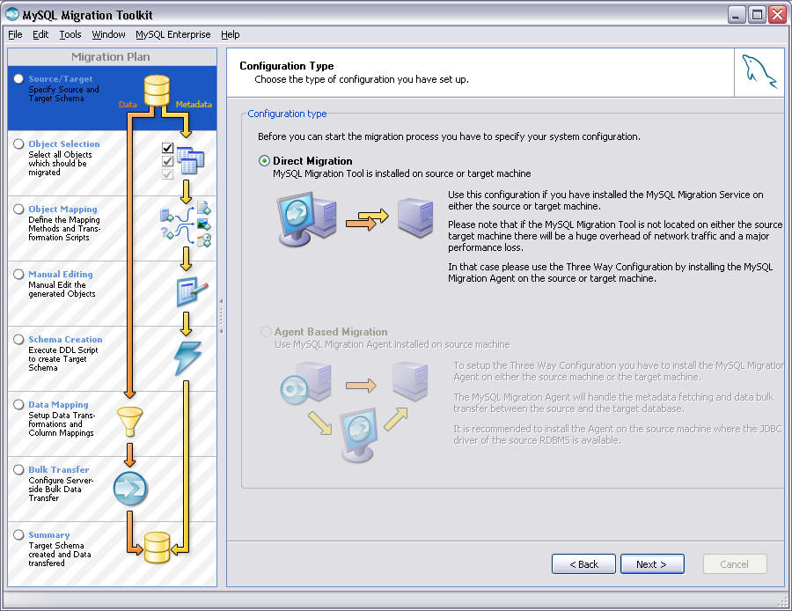  Figure 1 Configuration Type
4b | 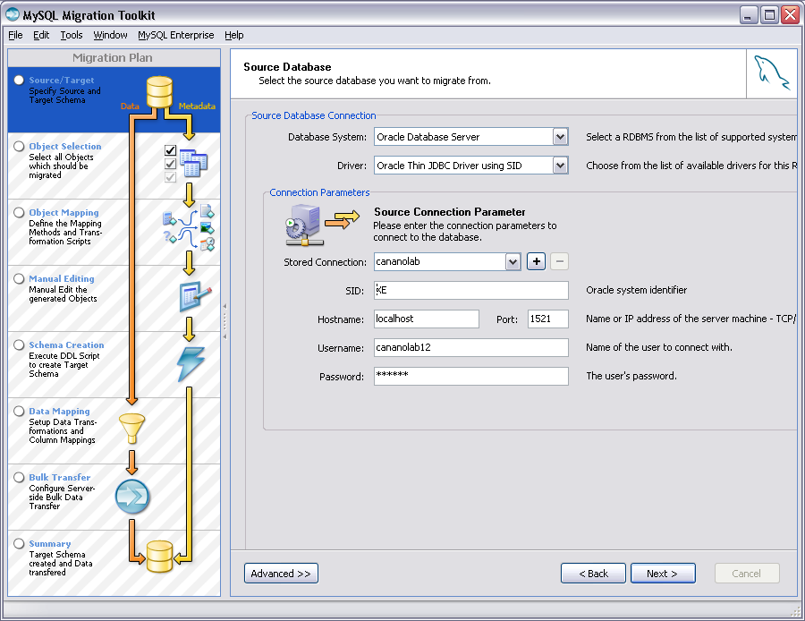  Figure 2 Source Database
4c | 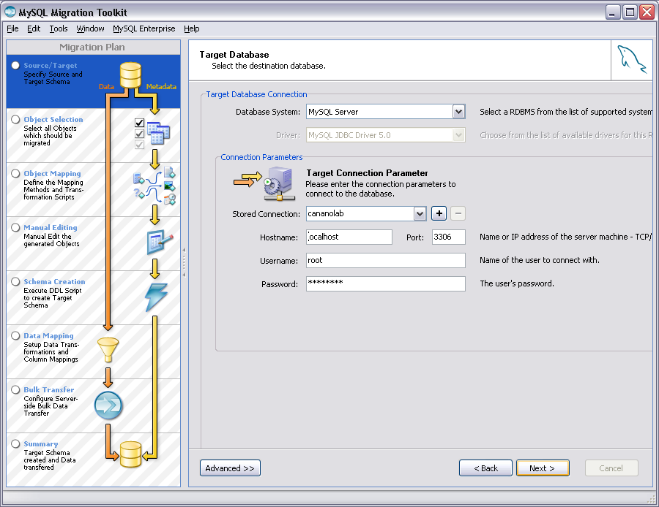  Figure 3 Target Database
4d | 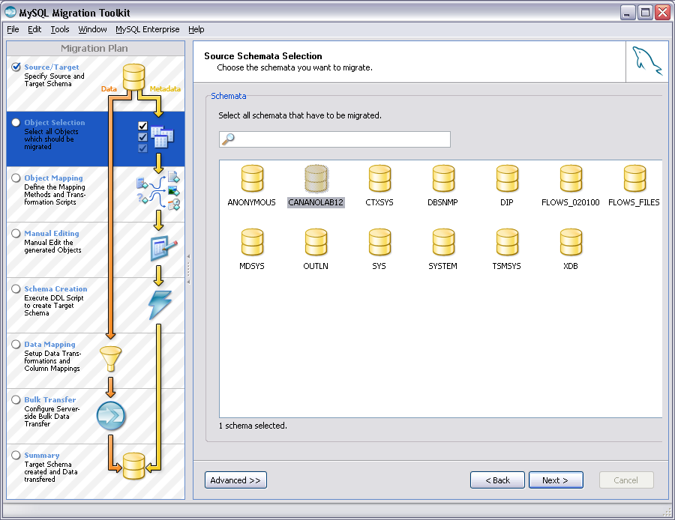  Figure 4 Source Schemata Selection
4e | 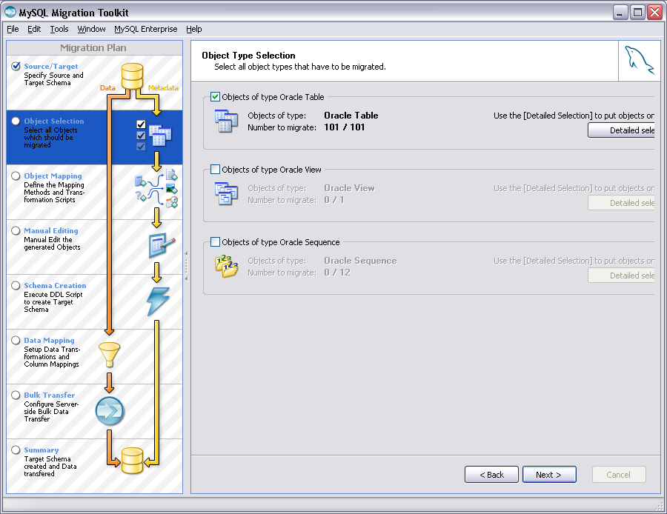  Figure 5 Object Type Selection
4f | 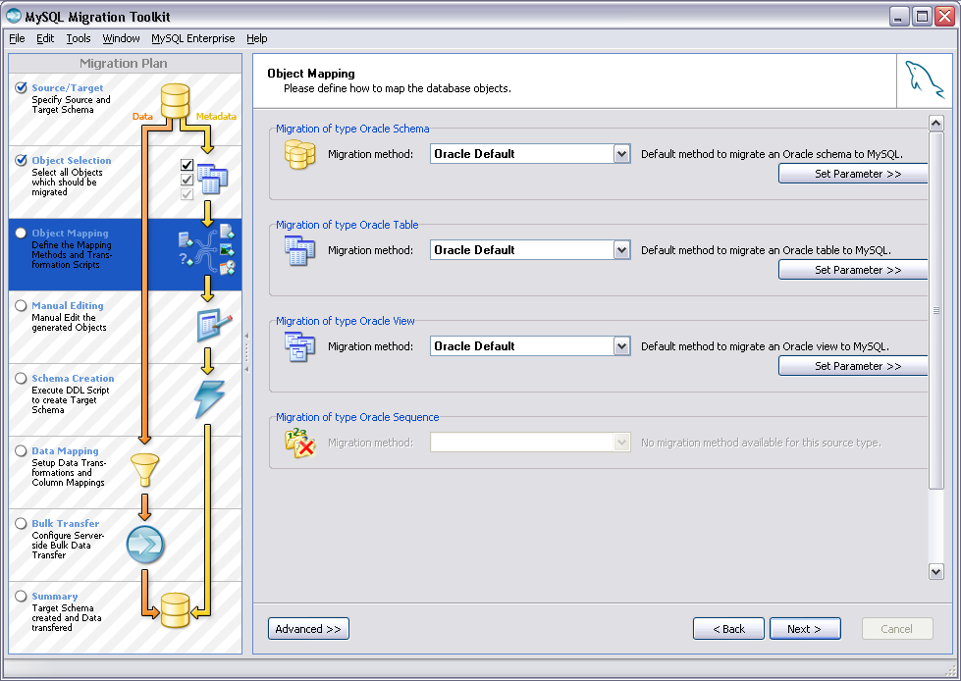  Figure 6 Object Mapping
4g | 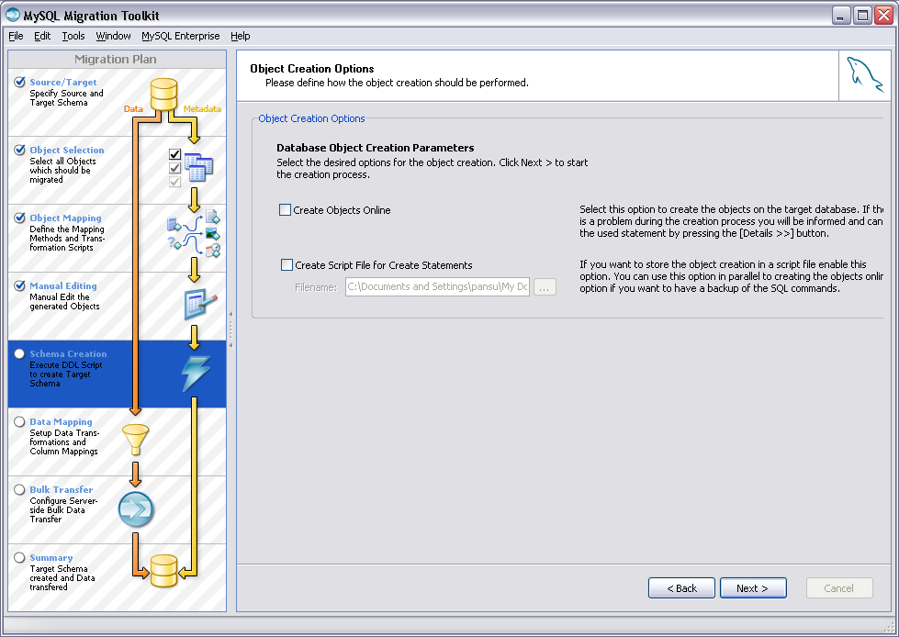  Figure 7 Object Creation Options (Make sure to uncheck the checkboxes.)
4h | 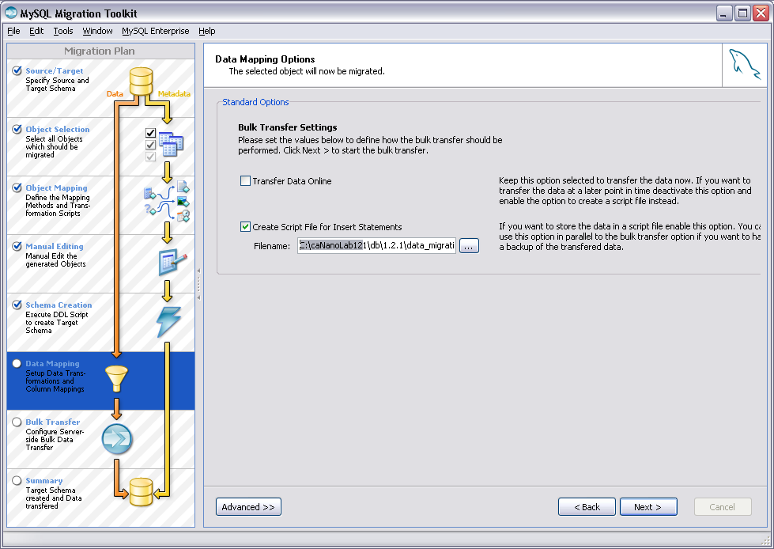  Figure 8 Data Mapping Options (Make sure to uncheck Transfer Data Online and check Create Script File for Insert Statements.)  .  Note: The Migration Toolkit GUI is used for generating insert statements only; there is no need to generate schema creation scripts.
5 | Edit the file generated in step 4 as follows:  - Replace all occurrences of word cananolab12 with word cananolab (assuming the Oracle schema that the MySQL database migrated from was cananolab12).
6 | Log into the MySQL database as the database administrator (root) and  execute the edited insert statements resulted from step 5.  Example: On a Windows XP system, assuming the SQL file resulted in step 5 is located at c:\caNanoLab1.2.1\db\1.2.1\insert_data_from_oracle.sql.  C:\>cd c:\caNanoLab_1.2.1\db\1.2.1  C:\>mysql –h localhost –u root –prootpass <insert_data_from_oracle.sql
7 | Create a user account and grant this user the following privileges to the schema cananolab: select, insert, delete, update and allow the user to connect from any hosts.  Example: Create a user account named cananolab_app with password go!234.  mysql>grant select, insert, delete, update on cananolab.* to ‘cananolab_app’@’%’ identified by ‘go!234’;  Note: User administration and schema privileges can also be managed by the MySQL Administrator GUI as a part of the MySQL 5.0 suite of GUI tools.

After data migration, refer to the Verification section on page 5 to verify that the migration has been successful. The same number of schema objects should be generated as described in that section.

caNanoLab Web Application

Assumptions and Requirements | The database has been installed and verified, as described on pages 3 and 5. Ant has been installed. The JBoss application server has been installed on a system (local or remote) and can be started at a designated port. JBoss install directory is referred as <JBOSS_HOME> in the document. The JBoss application server host URL is referred as <SERVER_URL>. It is assumed that the default configuration is used for deploying caNanoLab related web archive files; it is recommended that you change the designated port from the default port 8080 to another unused port.  For example, in the case of JBoss 4.0.5, the default configuration is located at the directory <JBOSS_HOME>/server/default. The caNanoLab web archive file shall be deployed at the directory <JBOSS_HOME>server/default/deploy. For changing the default port 8080 and associated ports, locate the file server.xml at the directory <JBOSS_HOME>/server/default/deploy/jbossweb-tomcat55.sar. Replace all occurrences of 8080, 8009 and 8443 with 18080, 18009 and 18443, respectively. For details, refer to the appropriate JBoss documentation.

Installation and Deployment | Follow these steps to install and deploy caNanoLab.

Step | Action
1 | Edit the Ant build properties file build.properties at <CANANOLAB_SOURCE> by specifying values for the following five properties:  - file.repository.dir: A directory on the system that hosts the JBoss application server for storing uploaded files, for example, c:\caNanoLab_Data.  Note: This directory should be writable by the user that starts the JBoss server, and this directory should be created prior to starting the application.  - sample.prefix: The prefix used for auto-accessioning samples, for example, NCL is used for sample accessions NCL-1, NCL-2, etc at the Nanoparticle Characterization Laboratory.  - application.owner: the owner of the caNanoLab release 1.2 installation instance, for example, NCL.  Note: This value should be the same as the appowner value used during data migration, described on page 5.  - grid.indexserver: the grid index server URL hosting the caNanoLab grid data services, for example, cagrid-index-qa.nci.nih.gov:8080, the NCICB’s QA caGrid index server.  - database: This property specifies whether the application works with an Oracle database or a MySQL database. For release 1.2.1 use mysql.
2 | Execute the Ant build script build.xml located at <CANANOLAB_SOURCE> with the default target build-application and the default build.properties file configured in step 1.  Example: Issue the following commands to execute the Ant script:  C:\>cd c:\caNanoLab_1.2  C:\>ant  Successful execution of the Ant script creates three deployable web archive war files in the directory <CANANOLAB_SOURCE>/output/war: caNanoLab.war, upt.war, and caNanoLabSDK.war. Place these war files into the default JBoss application server deploy directory, <JBOSS_HOME>/server/default/deploy.
3 | Copy the file mysql-connector-java-5.0.7-bin.jar from <CANANOLAB_SOURCE>/lib folder and place it in the directory <JBOSS_HOME>/server/default/lib/.

Common Security Module (CSM)
Before You Start caNanoLab | Before starting the JBoss application server and running the caNanoLab application, you must configure the server with required security configurations for user authentication and authorization. The caNanoLab web application relies on a modified version of NCICB CSM (Common Security Module) version 3.1 for user authentication and role-based authorization. For more information, see the CSM documentation at http://gforge.nci.nih.gov/frs/?group_id=12.

Follow these steps to complete the security configurations:

Step | Action
1 | Copy the file ApplicationSecurityConfig.xml from the directory <CANANOLAB_SOURCE>/conf/csm. Place it in the directory <JBOSS_HOME>/server/default/conf:
2 | Copy the file caNanoLab.csm.hibernate.cfg.xml from the directory <CANANOLAB_SOURCE>/conf/csm/mysql. Place it in the directory <JBOSS_HOME>/server/default/conf:
3 | Edit the file ApplicationSecurityConfig.xml at <JBOSS_HOME>/server/default/conf as follows:  - Replace the token @ABSOLUTE_PATH@ with the value <JBOSS_HOME>/server/default/conf, where <JBOSS_HOME> should be replaced by the actual full path JBoss install directory name, C:/jboss-4.0.5.GA.  Note: Either double back slashes \\ or a single forward slash / should be used as the file separator if working on Windows platform.
4 | Copy the file mysql-ds.xml from the directory <CANANOLAB_SOURCE>/conf and place it in the directory <JBOSS_HOME>/server/default/deploy, if such a file does not already exists. If a file named oracle-ds.xml exists in the directory <JBOSS_HOME>/server/default/deploy, remove it.
5 | Edit the copied file mysql-ds.xml at <JBOSS_HOME>/server/default/deploy as follows:  - Replace the token @DBSERVER@ with the URL or the IP address of the system that hosts the MySQL database, for example, 127.0.0.1.  - Replace the token @PORT@ with the port number of the database server, for example, 3306.  - Replace the token @DBNAME@ with the name of the database service to which to connect, for example, the value is cananolab for the MySQL Database created in the Database Technology Section Check with your Oracle DBA for your database service name configurations.  - Replace the token @DBUSER@ with the user name configured in step 1 of the Database Technology instructions on page 3, for example, cananolab_app.  - Replace the token @DBPASSWORD@ with the password associated with the value for the token @DBUSER@, for example, go!234.
6 | Locate the last </application-policy> tag in the file login-config.xml at <JBOSS_HOME>/server/default/conf, and insert the content of the file login-config-segment.xml at <CANANOLAB_SOURCE>/conf/csm/mysql into the file <JBOSS_HOME>/server/default/conf/login-config.xml just below the last </application-policy> tag.
7 | Edit the inserted file login-config.xml at <JBOSS_HOME>/server/default/conf by doing similar replacements as in step 4:  - Replace the token @DBSERVER@ with the URL or the IP address of the system that hosts the MySQL database, for example, 127.0.0.1.  - Replace the token @PORT@ with the port number of the database server, for example, 3306.  - Replace the token @DBNAME@ with the name of the database service to which to connect, for example, the value is cananolab for the MySQL Database created in the Database Technology Section Check with your Oracle DBA for your database service name configurations.  - Replace the token @DBUSER@ with the user name configured in step1 of the Database Technology instructions on page 3, for example, cananolab_app.  e. Replace the token @DBPASSWORD@ with the password associated with the value for the token @DBUSER@, for example, go!234.
8 | Locate the last </mbean> tag in the file properties-service.xml at <JBOSS_HOME>/server/default/deploy, and insert the content of the file properties-service-segment.xml at <CANANOLAB_SOURCE>/conf/csm into the file <JBOSS_HOME>/server/default/deploy/properties-service.xml just above the last </mbean> tag.
9 | Edit the inserted file properties-service.xml at <JBOSS_HOME>/server/default/deploy as follows:  - Replace the token @ABSOLUTE_PATH@ with the value <JBOSS_HOME>/server/default/conf, where <JBOSS_HOME> should be replaced by the actual full path JBoss install directory name, C:/jboss-4.0.5.GA.  Note: Either double back slashes \\ or a single forward slash / should be used as the file separator if working on Windows platform.

Verification | Once the JBoss application server is correctly configured with the CSM settings, you can now start the JBoss application server and start the caNanoLab application. Open the URL http://<SERVER_URL>/caNanoLab/ (for example, http://localhost:18080/caNanoLab). You should see a disclaimer page. Click on CLICKING HERE to go to the Welcome/Login page.

User Provisioning Tool (UPT)
Before users can log in to the caNanoLab application to submit and search data, you must first create their user accounts and assign them to the pre-defined user groups with the pre-defined roles to access the pre-defined protection groups. The caNanoLab application makes use of the NCICB’s User Provisioning Tool (UPT), a separate web application, for user account management. The concepts of users, groups, roles, protection groups are defined according the CSM/UPT principles. See the CSM documentation at http://gforge.nci.nih.gov/frs/?group_id=12 for details on these concepts and the use of the UPT tool.

NOTE: | As a part of the database seed data, a default user group Public has been created and has been assigned access to the SEARCH and the REMOTE SEARCH functions of the caNanoLab application. During the caNanoLab application start up, three more default users groups are auto-generated:  <application.owner>_Administrator  <application.owner>_Researcher  <application.owner>_PI  Where the value for <application.owner> is specified in the file build.properties prior to building the application as described on page 6.

In release 1.2, during the caNanoLab application start up, automatic roles are assigned for these three default user groups as follows:
- <application.owner>_Administrator is assigned access to the ADMINISTRATION function,
- <application.owner>_Researcher is assigned access to the WORKFLOW and the INVENTORY functions, and
- <application.owner>_PI is assigned access to the WORKFLOW, the INVENTORY and the SUBMIT functions.

UPT Example | The following steps illustrate an example use of the UPT tool to create a new user, to assign the user to be a caNanoLab administrator, and to assign the user to two pre-defined user groups.

Step | Action
1 | Launch the UPT tool at http://<SERVER_URL>/upt and login as superadmin/password. Use caNanoLab-upt as the application name when prompted at the UPT log in.  Note: The user superadmin was created as a part of the database setup.
2 | Once logged into the UPT tool, follow these steps:  - Select User > Create a New User.  - Create a new user account named admin.  - Select Application > Select an Existing Application; click Search.  - Select caNanoLab from the application list.  - Click View Details, then Associated Admins.  - Assign this user to be an administrator for the caNanoLab application.  - Click Update Association to commit the change.
3 | Log out of the UPT tool and log back in as admin/admin. Use caNanoLab as the application name when prompted at the UPT log in.  Note: When a new user account is created, its initial default password is the same as its login name. Given that the UPT tool is lacking a function for users to manage their own passwords, users can only update their passwords within the caNanoLab application. See the Notes below on how to update user passwords.
4 | Select User > Select an Existing User, and click Search. Select admin from the User list.  - Click View Details, then Associated Groups.  - Select <application.owner>_Adminstrator and Public groups from the pre-defined group list and assign them to the user.  - Click Update Associations to commit the change.

Follow similar steps to create other application user accounts and to assign them to different users groups, as appropriate.

NOTES: | - All users should be assigned to the Public group so everyone has access to the SEARCH and the REMOTE SEARCH functions.  - A user can be assigned to multiple user groups, for example, admin is assigned to both <application.owner>_Administrator and Public groups.  - The initial passwords for user accounts are set to be the same as their user accounts. When a user first logs into the caNanoLab application at http://<SERVER_URL>/caNanoLab, he/she would be prompted to change the initial password. Users can update their passwords at any time within the caNanoLab application.

For more information about how to use the UPT tool for managing user accounts, contact NCICB Application Support at ncicb@pop.nci.nih.gov and request that the caNanoLab technical team give you a demonstration of the UPT tool in the context of the caNanoLab application.

caNanoLab Grid Data Service

Assumptions and Requirements | Apache Tomcat has been downloaded and installed with the CATALINA_HOME environment variable set pointing to the Tomcat install directory. The Tomcat server URL is referred to as <TOMCAT_SERVER_URL> throughout the document.  Globus Toolkit has been downloaded and installed with the GLOBUS_LOCATION environment variable pointing to the Globus install directory. Apache Tomcat is assumed to be the grid service container.  The caNanoLab grid data service requires the caNanoLab web application war file caNanoLab.war be deployed, as well as caNanoLab SDK application service war file caNanoLabSDK.war be deployed to the same application server. Refer back to the caNanoLab web application installation and deployment section on page 12 for details on how to deploy these war files.

Installation and Deployment | Before deploying grid services, Tomcat must be pre-configured with a Globus web application that can host a grid service. Issue the following commands to complete the pre-configuration required for Tomcat to host a caNanoLab grid service:  C:>cd "%GLOBUS_LOCATION%"  C:>ant -f share\globus_wsrf_common\tomcat\tomcat.xml deployTomcat -Dtomcat.dir="%CATALINA_HOME%” –Dwebapp.name=wsrf-canano  This generates a directory <CATALINA_HOME>/webapps/wsrf-canano with the required Globus webapp information. Note that by specifying a webapp.name property (in the above command) to have a different value than the default value wsrf, multiple caCORE SDK backed grid services can be deployed to the same Tomcat server and function properly and independently without interference. This circumvents the current known issue with multiple caCore SDK-backed grid services interfering with each other if deployed to the same Globus webapp wsrf under the same Tomcat server.

Once the Tomcat server is pre-configured, complete the following steps to create and deploy a caNanoLab grid data service:

Step | Action
1 | Extract caNanoLab_grid_1.1.zip to a location on your local machine such as the C drive. This location is referred as <CANANOLAB_GRID_SOURCE> throughout the document.
2 | By default, the caNanoLab grid data service is registered to the NCICB caGrid 1.0 QA index service. To change the index service URL, open the file deploy.properties at <CANANOLAB_GRID_SOURCE> and edit the property index.service.url to be your choice of caGrid index server.
3 | Edit the file serviceMetadata.xml at <CANANOLAB_GRID_SOURCE>/etc/ as follows:  - Replace the contents in the tag <ns1:hostingResearchCenter> with your hosting center information.  Note: The value for the attribute displayName is used in the caNanoLab web application as the grid node host name to distinguish different remote caNanoLab grid services.
4 | Execute the Ant build file (build.xml) located at <CANANOLAB_GRID_SOURCE> with the following two build properties and the task createTomcatDeploymentTar:  cananolab.sdk.host =<SERVER_URL> (e.g. localhost:8080)  webapp.name = wsrf-canano  Execution of the Ant build script generates a file CaNanoLabSvc.tar at the <CANANOLAB_GRID_SOURCE>/output directory.
5 | Place the file CaNanoLabSvc.tar to the directory <CATALINA_HOME> and extract the tar file within the same directory.
6 | For the caNanoLab grid service to successfully register with the index server, edit the file server-config.wsdd at <CATALINA_HOME>/webapps/wsrf-canano/WEB-INF/etc/globus_wsrf_core as follows:  - Add a logicalHost parameter, with the value being the public IP address or the public hostname for the Tomcat server. For example:  <globalConfiguration>  ...  <parameter name="sendXsiTypes" value="true"/>  <parameter name="logicalHost" value="<TOMCAT_SERVER_URL>"/>  <parameter name="publishHostName" value="true"/>
7 | Start the tomcat server to deploy the grid service.

Verification | To verify the creation of the caNanoLab grid data service, open the URL http://<TOMCAT_SERVER_URL>/wsrf-canano/services/cagrid/CaNanoLabSvc. You should see a page that says:  cagrid/CaNanoLabSvc  Hi there, this is an AXIS service!  Log into the caNanoLab application, and select REMOTE SEARCH > Nanoparticles. You should see the display name for the research center you specified earlier listed as one of the remote grid node hosts.

For more information and help on caGrid service configuration and deployment, refer to the caGrid wiki page: http://www.cagrid.org.

If you need further assistance on setting a caNanoLab grid service, contact NCICB Application Support at ncicb@pop.nci.nih.gov.

Contacting Application Support

NCICB Application Support | http://ncicb.nci.nih.gov/NCICB/support  Telephone: 301-451-4384  Toll free: 888-478-4423

